Amazon Sales Service
- Project Title / Headline
Amazon Sales Service Dashboard & Analytics System
A complete data analytics project designed to analyze Amazon sales performance, customer behavior, product trends, and revenue insights using modern data analysis and visualization tools. The project helps businesses make data-driven decisions through interactive dashboards and actionable insights.

- Features / Highlights
📊 Sales Performance Analysis
- Analyze total sales, profit, and revenue trends
- Monthly, quarterly, and yearly sales tracking
- Region-wise and category-wise performance insights
🛒 Product Insights
- Top-selling products identification
- Product category performance analysis
- High-profit and low-performing product detection
👥 Customer Analytics
- Customer purchasing behavior analysis
- Repeat customer tracking
- Customer segmentation insights
🌍 Geographic Analysis
- State-wise and city-wise sales visualization
- Regional sales comparison
- Market expansion opportunity identification
📈 Interactive Dashboards
- Dynamic Power BI dashboards
- Filters for category, region, and time period
- KPI cards and trend visualizations
⚡ Business Intelligence
- Revenue forecasting support
- Profitability analysis
- Strategic decision-making insights

- Tech Stack
Programming & Query Languages
- Python
- SQL
Data Analysis Libraries
- Pandas
- NumPy
Data Visualization
- Power BI
- Matplotlib
- Seaborn
Database
- MySQL
Tools & Platforms
- Jupyter Notebook
- Microsoft Excel
- Git & GitHub

Project Workflow
- Data Collection
- Data Cleaning & Preprocessing
- Exploratory Data Analysis (EDA)
- Data Visualization
- Dashboard Development in Power BI
- Business Insights Generation
- Reporting & Documentation

Expected Outcomes
- Improved understanding of sales trends
- Better inventory and product planning
- Enhanced customer targeting strategies
- Data-driven business decision support

Future Enhancements
- Machine Learning sales forecasting
- Real-time dashboard integration
- Automated reporting system
- Customer recommendation engine

Screenshots / Demos
Show what the dashboard looks like. Example:
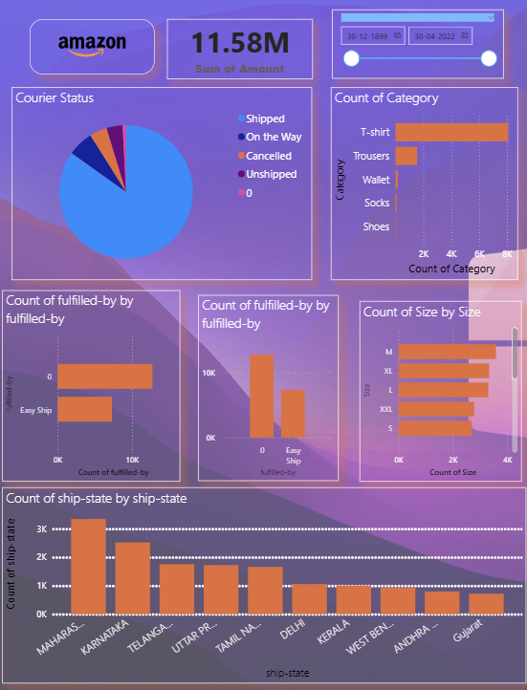

Author
Ankur Shukla
Data Analytics & Business Intelligence Enthusiast

